CO5 – AT2
Name: Mandati Sharan Mahi Reddy
Reg No: 192324082

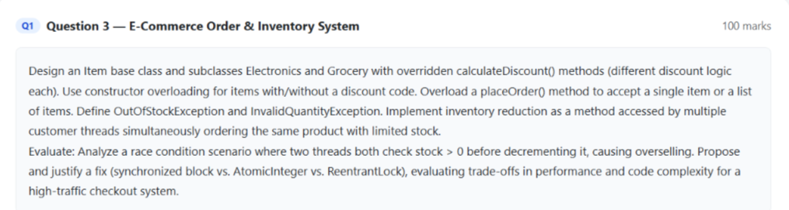

Code:
import java.util.*;
public class Main {
static class OutOfStockException extends Exception {
OutOfStockException(String message) {
super(message);
}
}
static class InvalidQuantityException extends Exception {
InvalidQuantityException(String message) {
super(message);
}
}
static abstract class Item {
String name;
double price;
String code;

Item(String name, double price) {
this.name = name;
this.price = price;
}

Item(String name, double price, String code) {
this.name = name;
this.price = price;
this.code = code;
}

abstract double calculateDiscount();
}

static class Electronics extends Item {
Electronics(String name, double price) {
super(name, price);
}

Electronics(String name, double price, String code) {
super(name, price, code);
}

double calculateDiscount() {
return "ELEC10".equals(code) ? price * 0.10 : 0;
}
}

static class Grocery extends Item {
Grocery(String name, double price) {
super(name, price);
}

Grocery(String name, double price, String code) {
super(name, price, code);
}

double calculateDiscount() {
return "GROC5".equals(code) ? price * 0.05 : 0;
}
}

static class Inventory {
int stock;

Inventory(int stock) {
this.stock = stock;
}

synchronized void reduceStock(int quantity)
throws OutOfStockException, InvalidQuantityException {

if (quantity <= 0)
throw new InvalidQuantityException("Invalid quantity");

if (quantity > stock)
throw new OutOfStockException("Out of stock");

stock -= quantity;

System.out.println(Thread.currentThread().getName()
+ " bought " + quantity
+ ", Stock = " + stock);
}
}

static class Order {
Inventory inventory;

Order(Inventory inventory) {
this.inventory = inventory;
}

void placeOrder(Item item, int quantity) {
try {
inventory.reduceStock(quantity);

double total =
(item.price - item.calculateDiscount()) * quantity;

System.out.println(Thread.currentThread().getName()
+ " ordered " + item.name
+ ", Total = " + total);

} catch (Exception e) {
System.out.println(Thread.currentThread().getName()
+ " : " + e.getMessage());
}
}

void placeOrder(Item item) {
placeOrder(item, 1);
}
}

public static void main(String[] args) {

Electronics laptop =
new Electronics("Laptop", 50000, "ELEC10");

Grocery rice =
new Grocery("Rice", 1000, "GROC5");

System.out.println("Laptop Discount = "
+ laptop.calculateDiscount());

System.out.println("Rice Discount = "
+ rice.calculateDiscount());

Inventory inventory = new Inventory(5);
Order order = new Order(inventory);

order.placeOrder(rice);

Thread customer1 = new Thread(
() -> order.placeOrder(laptop, 3),
"Customer-1");

Thread customer2 = new Thread(
() -> order.placeOrder(laptop, 3),
"Customer-2");

customer1.start();
customer2.start();

try {
customer1.join();
customer2.join();
} catch (InterruptedException e) {
Thread.currentThread().interrupt();
}

System.out.println("Final Stock = " + inventory.stock);
}
}

Output:
Laptop Discount = 5000.0
Rice Discount = 50.0
main bought 1, Stock = 4
main ordered Rice, Total = 950.0
Customer-1 bought 3, Stock = 1
Customer-1 ordered Laptop, Total = 135000.0
Customer-2 : Out of stock
Final Stock = 1

